R-26.7
minimize: 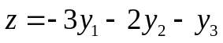
subject to: 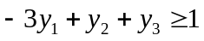
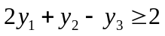
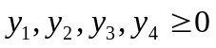
Augment matrix:
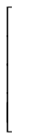 | -3 | 1 | 1 | 1 | 
 | 2 | 1 | -1 | 2
 | 3 | 2 | 1 | 0

Transpose matrix:
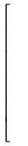 | -3 | 2 | 3 | 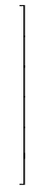
 | 1 | 1 | 2
 | 1 | -1 | 1
 | 1 | 2 | 0

Standard form is:
maximize: 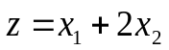
subject to: 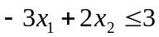
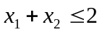
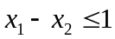
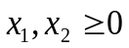

Slack form:
maximize:
subject to: 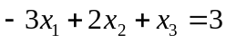
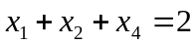
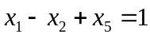
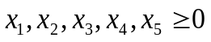
Pivot x2 and x3 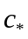 = 3
maximize: 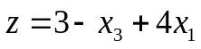
subject to:
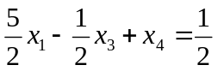
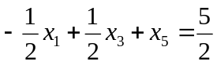

Pivot x1 and x4 = 3.8
maximize: 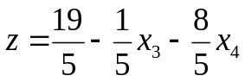
subject to: 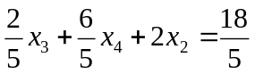
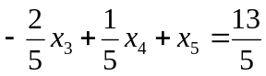

Now, both coefficients is negative, so the optimal value is 19 / 5 = 3.8, with x1 = 1 / 5, x2 = 9 / 5.

